Topic         –  Self-study website

Driving question – How can we create social impact websites that will provide opportunities for a better living environment in the community?

Essential question – How can web technology assist learners who are seeking great support for lower-secondary academics that specialize in science?

Aim           –   To help students perfect their studies, especially in lower secondary Science by providing a collection of main concepts and notes in each specific topic and to create a fun and motivating self-study place for students, especially for those who prefer bullet points and visual representation over long paragraphs.

Website Name       –  Academic Diary

Slogan –  Reflect & Refine with us to seize your Academic Validation

Logo –

Color theme –

#388087

#6FB3B8

#BADFE7

#C2EDCE

#F6F6F2

Font Styles:

‘Amiri Quran', serif – title

'Didact Gothic', sans-serif – p

Inspired websites:

<https://www.khanacademy.org/science/physics/electric-charge-electric-force-and-voltage>

<https://www.education.com/resources/>

[ttps://flexbooks.ck12.org/cbook/ck-12-physics-flexbook-2.0/section/3.2/primary/lesson/friction-phys/](https://flexbooks.ck12.org/cbook/ck-12-physics-flexbook-2.0/section/3.2/primary/lesson/friction-phys/)

<https://www.socrative.com/>

**References**

Content reference: *Cambridge Checkpoint Science Coursebook 9*

Slider 1 Image - <https://www.aesdes.org/2021/01/26/academia-aesthetic-exploration/>

Purpose Image - <https://bootcamp.uxdesign.cc/i-just-completed-3-years-as-a-designer-here-are-9-crucial-things-i-learned-89c31f67a45e>

*Design Inspiration*

NavBar:



Slider-2:



Footer:

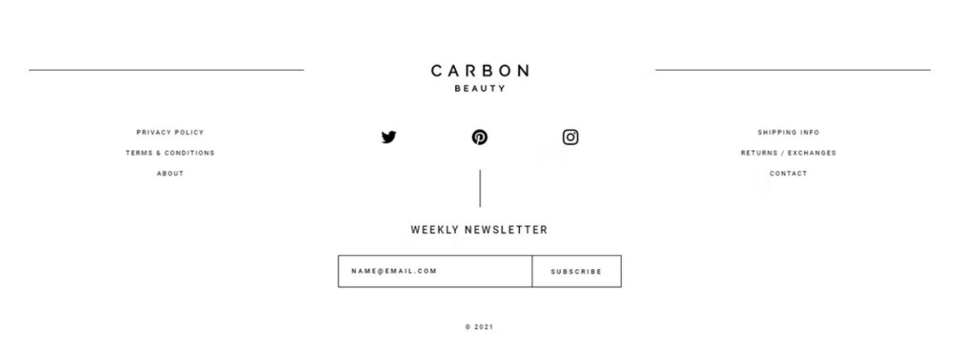

Home Page

[*https://www.pinterest.com/pin/791648440741356078/*](https://www.pinterest.com/pin/791648440741356078/)

[*https://shanedowling.com/learning-python-as-a-platform-engineer-first-steps-911e59dd4af8*](https://shanedowling.com/learning-python-as-a-platform-engineer-first-steps-911e59dd4af8)

Subject Page

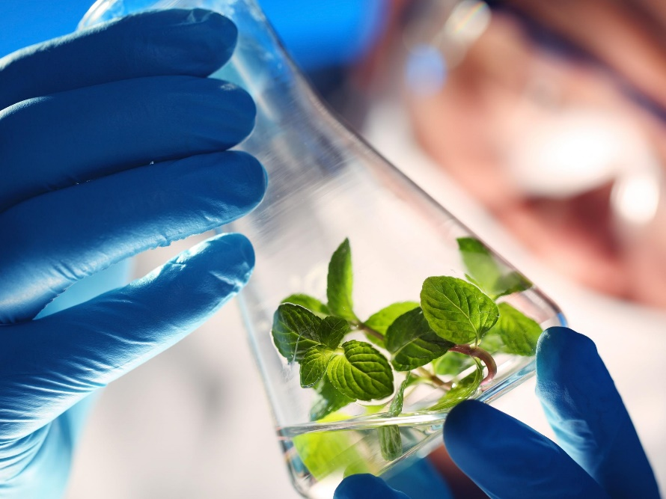

[*https://www.independent.co.uk/news/science/us-military-gm-plants-spy-gentically-modified-research-development-sensors-environments-a8071646.html*](https://www.independent.co.uk/news/science/us-military-gm-plants-spy-gentically-modified-research-development-sensors-environments-a8071646.html)

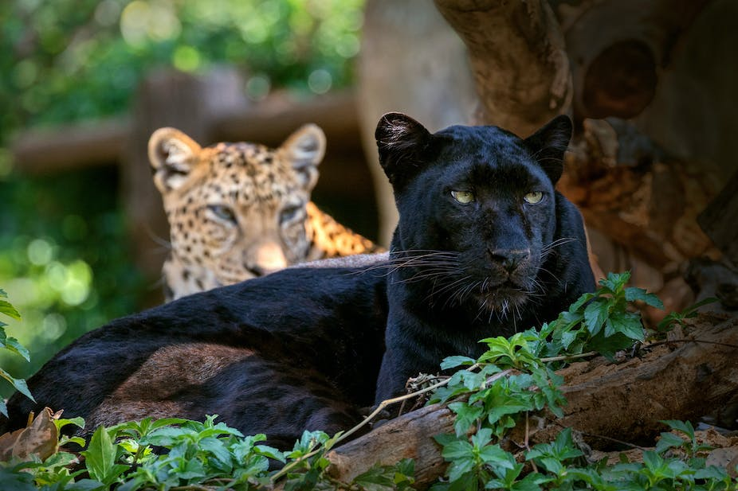

[*https://theconversation.com/the-why-what-and-where-of-the-worlds-black-leopards-112674*](https://theconversation.com/the-why-what-and-where-of-the-worlds-black-leopards-112674)



[*https://www.medicaldevice-network.com/news/ai-accurately-predicts-genetic-mutation-effects-genome-dark-matter/*](https://www.medicaldevice-network.com/news/ai-accurately-predicts-genetic-mutation-effects-genome-dark-matter/)

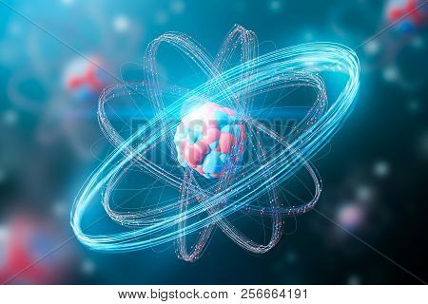

[*https://www.bigstockphoto.com/image-256664191/stock-photo-red-and-blue-abstract-atom-nucleus-model-over-a-blurred-red-blue-atoms-background-concept-of-scienc*](https://www.bigstockphoto.com/image-256664191/stock-photo-red-and-blue-abstract-atom-nucleus-model-over-a-blurred-red-blue-atoms-background-concept-of-scienc)

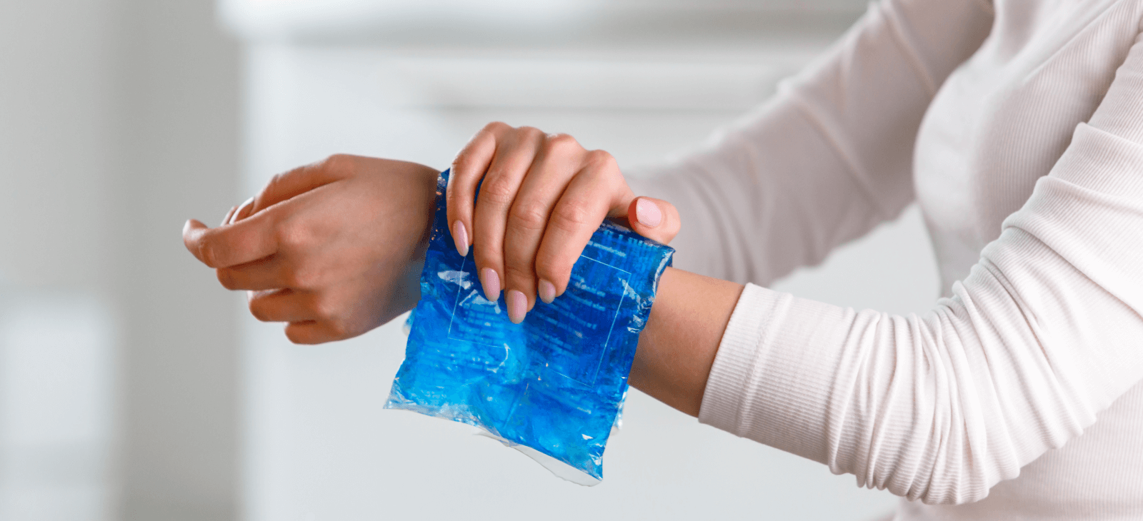

[*https://www.calmclinic.com/anxiety/signs/affected-hands*](https://www.calmclinic.com/anxiety/signs/affected-hands)

*https://www.sciencephoto.com/media/706408/view/reaction-rate*

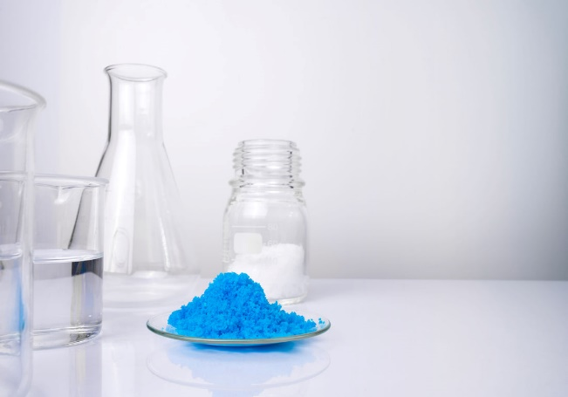

[*https://standishmilling.com/blogs/articles/copper-sulfate-uses-a-complete-list*](https://standishmilling.com/blogs/articles/copper-sulfate-uses-a-complete-list)

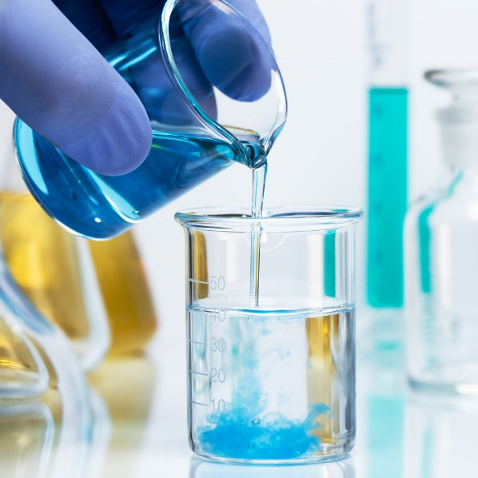

[*http://gujaratpetro.in/*](http://gujaratpetro.in/)

[*https://www.facom.com/fi/products/101-Series-Description.html*](https://www.facom.com/fi/products/101-Series-Description.html)

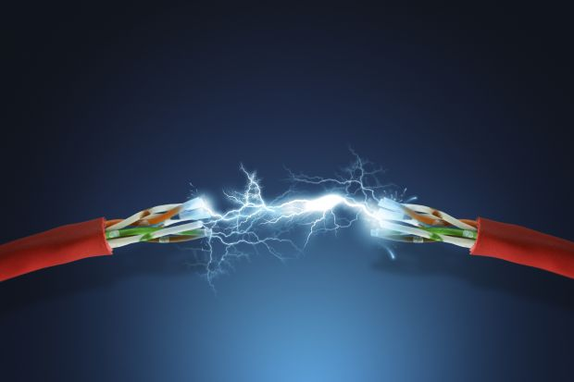

[*https://www.timeshighereducation.com/news/not-all-top-scientists-have-first-says-study*](https://www.timeshighereducation.com/news/not-all-top-scientists-have-first-says-study)

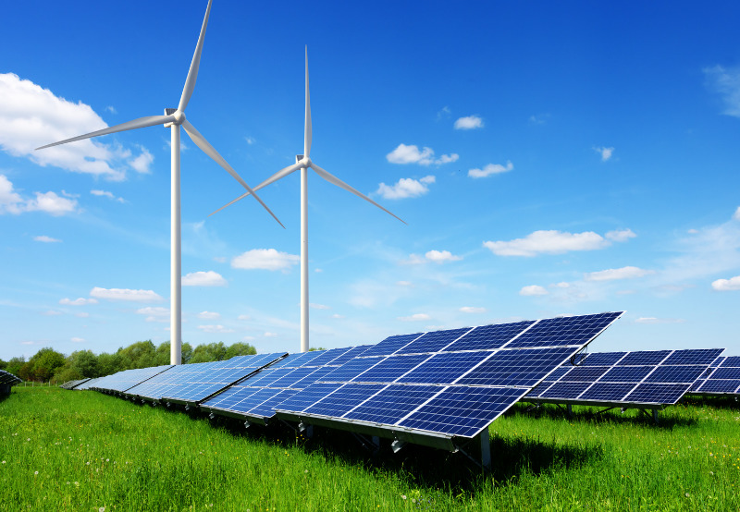

[*https://www.mercomindia.com/adani-green-288-million-solar-wind-hybrid-rajasthan*](https://www.mercomindia.com/adani-green-288-million-solar-wind-hybrid-rajasthan)

Events Page

[*https://www.safetyandhealthmagazine.com/articles/23288-chemical-safety-board-reminds-schools-of-hazards-in-chemistry-labs*](https://www.safetyandhealthmagazine.com/articles/23288-chemical-safety-board-reminds-schools-of-hazards-in-chemistry-labs)

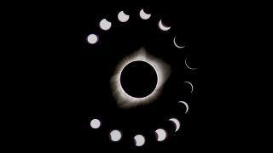

[*https://www.space.com/15584-solar-eclipses.html*](https://www.space.com/15584-solar-eclipses.html)

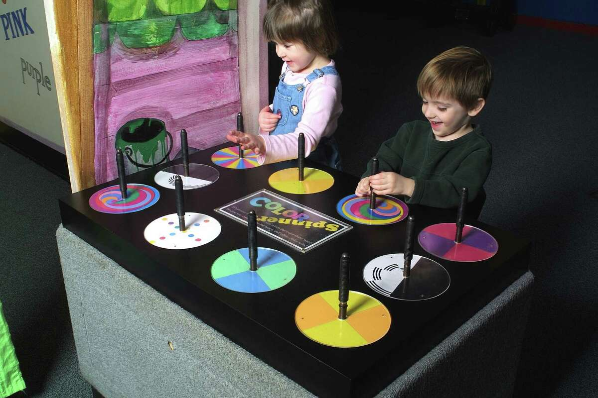

[*https://www.ctpost.com/news/article/Traveling-show-on-art-science-of-color-comes-to-3982314.php*](https://www.ctpost.com/news/article/Traveling-show-on-art-science-of-color-comes-to-3982314.php)



[*https://www.prometheanworld.com/gb/resource-centre/blogs/science-games-for-key-stage-3/*](https://www.prometheanworld.com/gb/resource-centre/blogs/science-games-for-key-stage-3/)

Tools Page

[*https://www.pinterest.com/pin/474848354439265000/*](https://www.pinterest.com/pin/474848354439265000/)

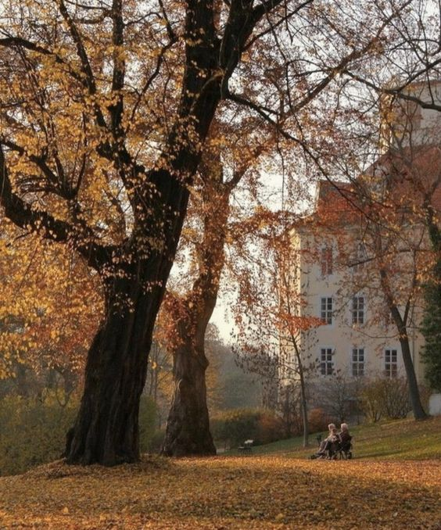

[*https://www.pinterest.com/pin/479211216607925604/*](https://www.pinterest.com/pin/479211216607925604/)

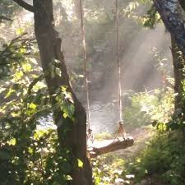

[*https://www.pinterest.com/pin/793055815637518515/*](https://www.pinterest.com/pin/793055815637518515/)

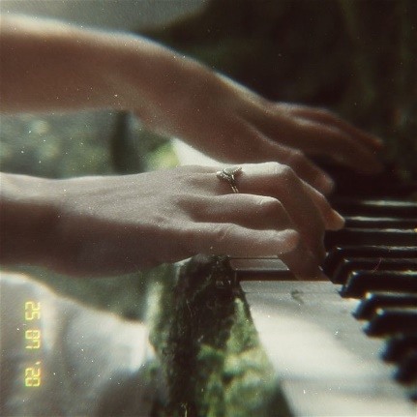

[*https://www.pinterest.com/pin/2674081021755859/*](https://www.pinterest.com/pin/2674081021755859/)

[*https://www.tripadvisor.com/Attractions-g1055356-Activities-Candiolo_Province_of_Turin_Piedmont.html*](https://www.tripadvisor.com/Attractions-g1055356-Activities-Candiolo_Province_of_Turin_Piedmont.html)

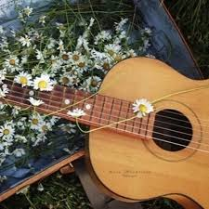

[*https://soundcloud.com/ashwikasings/teardrops-on-my-guitar-taylor-swift-cover*](https://soundcloud.com/ashwikasings/teardrops-on-my-guitar-taylor-swift-cover)

[*https://www.pinterest.com/pin/7951736833498238/*](https://www.pinterest.com/pin/7951736833498238/)

[*https://www.pinterest.com/pin/3799980927417728/*](https://www.pinterest.com/pin/3799980927417728/)

[*https://thecoffeepurist.tumblr.com/post/622814195078070272*](https://thecoffeepurist.tumblr.com/post/622814195078070272)

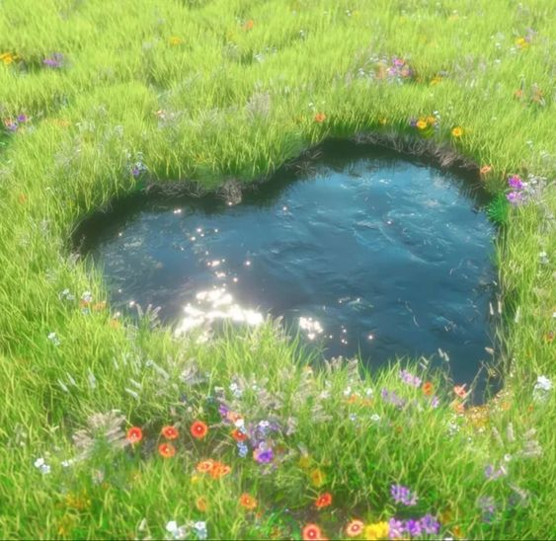

[*https://www.pinterest.com/pin/446982331780912572/*](https://www.pinterest.com/pin/446982331780912572/)

About Page

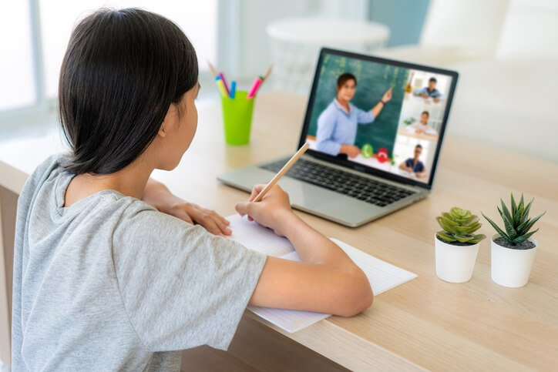

[*https://onlinedegrees.sandiego.edu/online-teaching-strategies/*](https://onlinedegrees.sandiego.edu/online-teaching-strategies/)

Plants Page

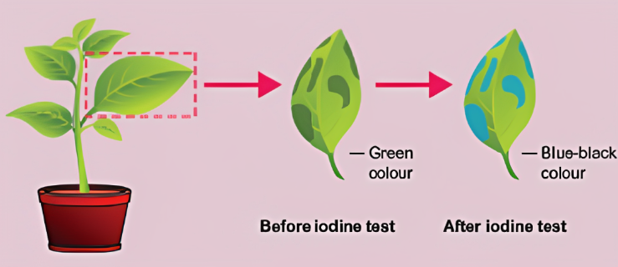

[*https://samacheerkalvi.guru/samacheer-kalvi-9th-science-solutions-chapter-19/*](https://samacheerkalvi.guru/samacheer-kalvi-9th-science-solutions-chapter-19/)

[*https://chemicalwatch.com/256544/sulfuric-acid-sector-voices-concern-over-proposed-vanadium-pentoxide-classification*](https://chemicalwatch.com/256544/sulfuric-acid-sector-voices-concern-over-proposed-vanadium-pentoxide-classification)

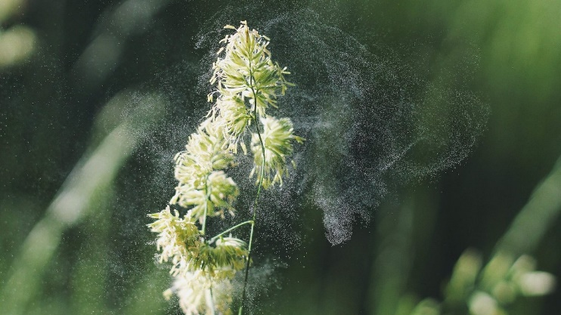

[*https://www.cleveland19.com/2020/02/11/cleveland-doctor-warning-what-could-be-terrible-allergy-season-thanks-tame-winter/*](https://www.cleveland19.com/2020/02/11/cleveland-doctor-warning-what-could-be-terrible-allergy-season-thanks-tame-winter/)

Living things in their environment Page

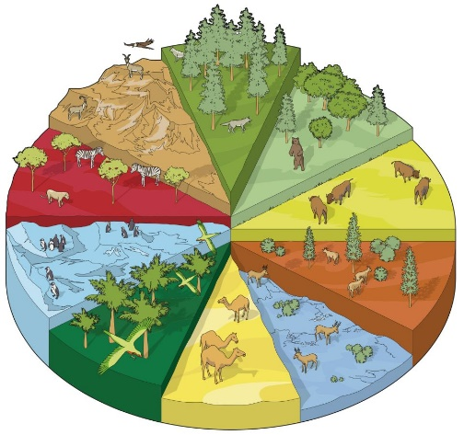

[*https://www.dkfindout.com/us/quiz/animals-and-nature/habitats-quiz/*](https://www.dkfindout.com/us/quiz/animals-and-nature/habitats-quiz/)

[*https://www.kamilgrzybek.com/blog/categories/dotnet*](https://www.kamilgrzybek.com/blog/categories/dotnet)

[*https://www.doorsblacksea.eu/region*](https://www.doorsblacksea.eu/region)

Variation and inheritance Page

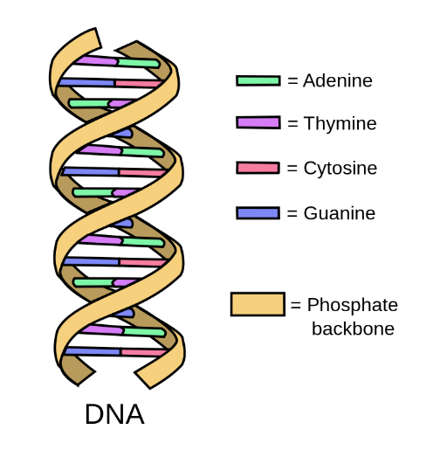 [*https://bio.libretexts.org/Courses/Lumen_Learning/Biology_for_Non-Majors_I_(Lumen)/08%3A_DNA_Structure_and_Replication/8.02%3A_Storing_Genetic_Information*](https://bio.libretexts.org/Courses/Lumen_Learning/Biology_for_Non-Majors_I_(Lumen)/08%3A_DNA_Structure_and_Replication/8.02%3A_Storing_Genetic_Information)

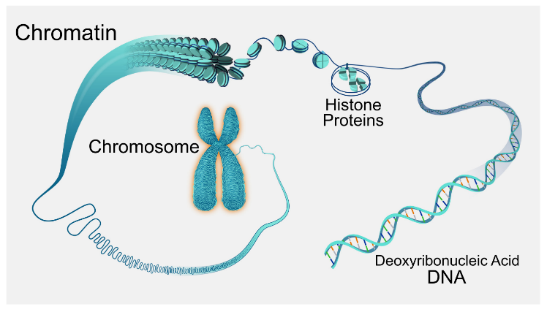

[*https://pressbooks.pub/humanbiology/chapter/biology-of-the-cell/*](https://pressbooks.pub/humanbiology/chapter/biology-of-the-cell/)

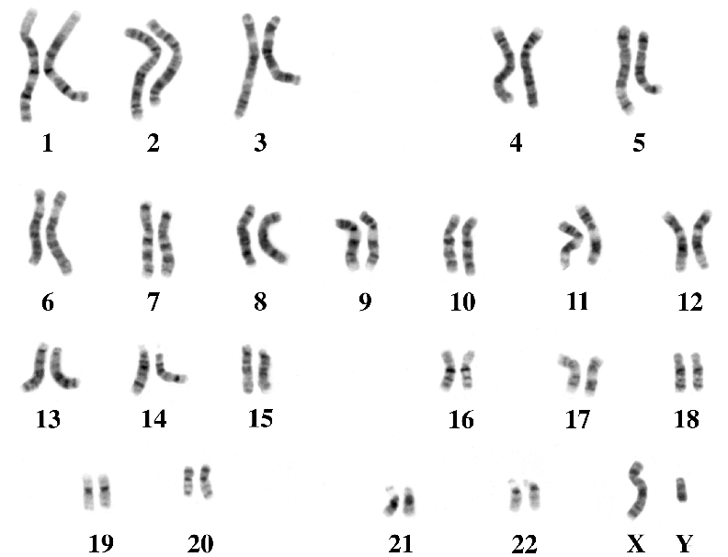

[*https://www.researchgate.net/figure/A-karyotype-of-a-human-genetic-male-shows-the-genomes-23-pairs-of-chromosomes_fig2_316801394*](https://www.researchgate.net/figure/A-karyotype-of-a-human-genetic-male-shows-the-genomes-23-pairs-of-chromosomes_fig2_316801394)

Material properties Page

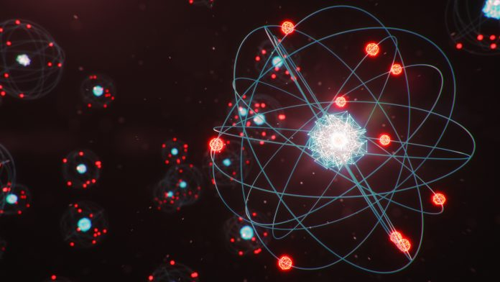

[*https://www.innovationnewsnetwork.com/linking-atomic-nuclei-size-blackhole-thermodynamic-principles/15596/*](https://www.innovationnewsnetwork.com/linking-atomic-nuclei-size-blackhole-thermodynamic-principles/15596/)

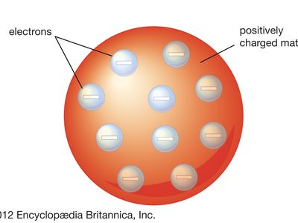

[*https://www.britannica.com/science/Thomson-atomic-model*](https://www.britannica.com/science/Thomson-atomic-model)

[*https://www.vedantu.com/evs/uses-of-transition-metals*](https://www.vedantu.com/evs/uses-of-transition-metals)

Energy changes Page

[*https://www.chemistrylearner.com/chemical-reactions/endothermic-reaction*](https://www.chemistrylearner.com/chemical-reactions/endothermic-reaction)

[*https://www.chemistrylearner.com/chemical-reactions/exothermic-reaction*](https://www.chemistrylearner.com/chemical-reactions/exothermic-reaction)

Reactivity Page

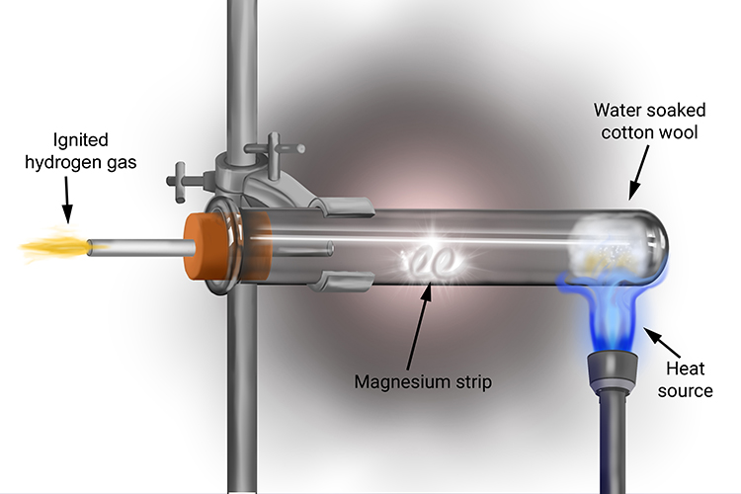

[*https://mammothmemory.net/chemistry/the-metal-reactivity-series/potassium-sodium-lithium-and-calcium-reactions-with-steam/potassium-sodium-lithium-and-calcium-reactions-with-steam/magnesium-and-steam.html*](https://mammothmemory.net/chemistry/the-metal-reactivity-series/potassium-sodium-lithium-and-calcium-reactions-with-steam/potassium-sodium-lithium-and-calcium-reactions-with-steam/magnesium-and-steam.html)

[*https://qr.ae/pyG2q4*](https://qr.ae/pyG2q4)

[*https://www.pinterest.com/pin/28217935154691510/*](https://www.pinterest.com/pin/28217935154691510/)

Salts Page

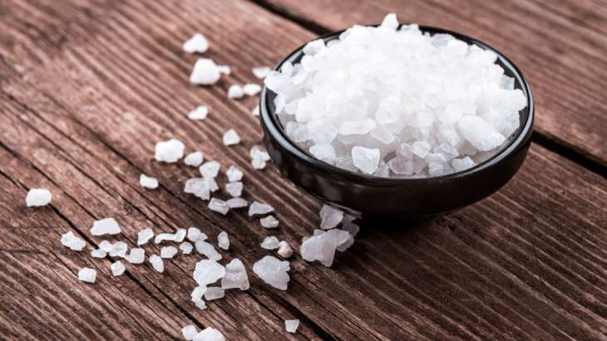

[*https://www.indiatvnews.com/science/news-plastic-in-salt-we-consume-iit-bombay-s-startling-revelation-in-new-study-461286*](https://www.indiatvnews.com/science/news-plastic-in-salt-we-consume-iit-bombay-s-startling-revelation-in-new-study-461286)

*https://missouripoisoncenter.org/is-this-a-poison/chalk/*

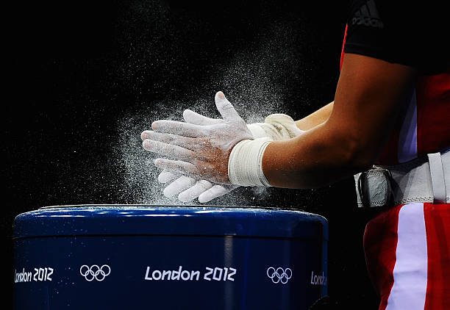

[*https://www.gettyimages.com/photos/silvana-saldarriaga*](https://www.gettyimages.com/photos/silvana-saldarriaga)

Rates of reaction Page

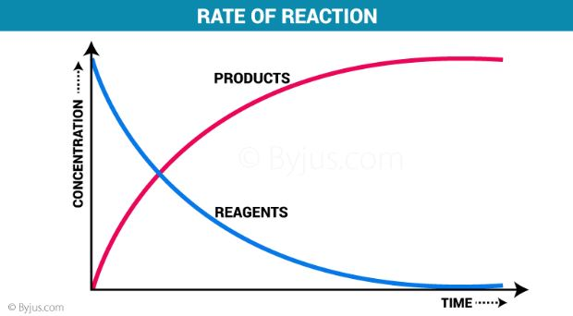

[*https://byjus.com/chemistry/rate-of-reaction-questions/*](https://byjus.com/chemistry/rate-of-reaction-questions/)

[*http://goddesslovesicecream.blogspot.com/2016/10/cie-level-chemistry-paper-3-tips.html*](http://goddesslovesicecream.blogspot.com/2016/10/cie-level-chemistry-paper-3-tips.html)

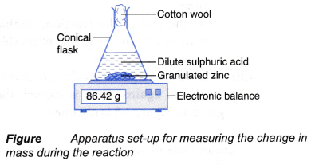

[*https://www.aplustopper.com/calculate-reaction-rate/*](https://www.aplustopper.com/calculate-reaction-rate/)

Forces in action Page

[*https://slideplayer.com/slide/14923777/*](https://slideplayer.com/slide/14923777/)

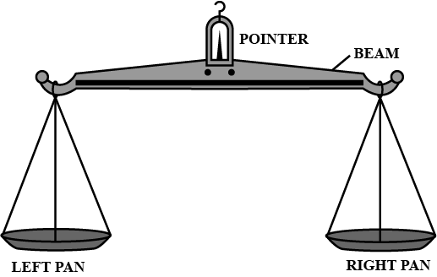

[*https://www.toppr.com/ask/question/name-the-instrument-which-is-commonly-used-to-measure-the-mass-of-a-body-state/*](https://www.toppr.com/ask/question/name-the-instrument-which-is-commonly-used-to-measure-the-mass-of-a-body-state/)

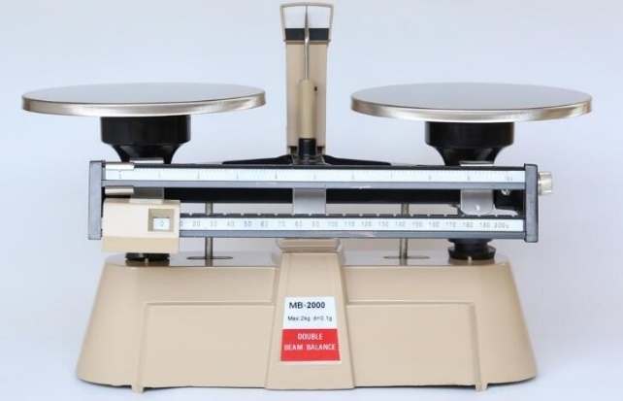

[*https://www.canfortlab.com/Triple-Beam-Balance-&-Double-Beam-Balance-which-one-to-choose-n20.html*](https://www.canfortlab.com/Triple-Beam-Balance-&-Double-Beam-Balance-which-one-to-choose-n20.html)

Electricity Page

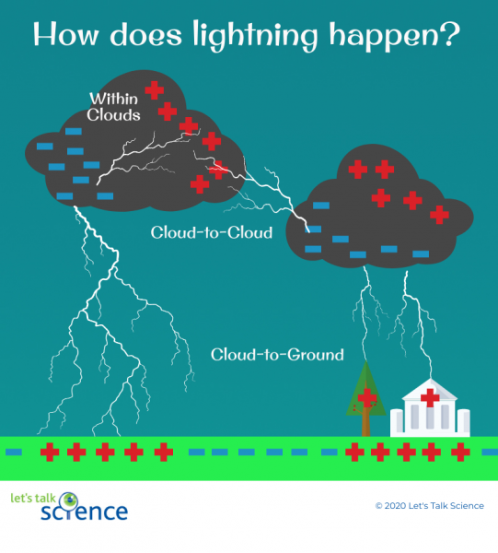

[*https://letstalkscience.ca/educational-resources/stem-in-context/thundersnow-winter-thunderstorms*](https://letstalkscience.ca/educational-resources/stem-in-context/thundersnow-winter-thunderstorms)

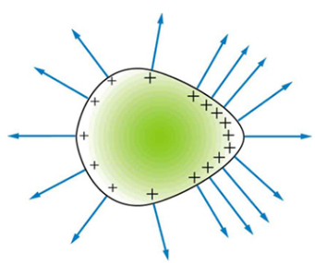

[*https://physics.stackexchange.com/questions/716391/charge-distribution-and-shape*](https://physics.stackexchange.com/questions/716391/charge-distribution-and-shape)

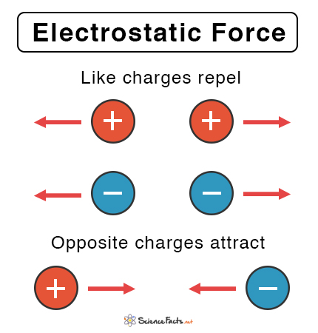

[*https://www.inspiritvr.com/general-physics/static-electricity/electric-charge-and-electric-force-study-guide*](https://www.inspiritvr.com/general-physics/static-electricity/electric-charge-and-electric-force-study-guide)

Energy Page

[*https://www.youtube.com/watch?v=hvBHxnoYqXo*](https://www.youtube.com/watch?v=hvBHxnoYqXo)

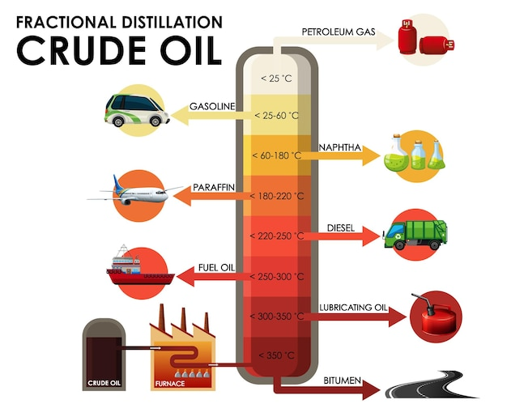

[*https://www.freepik.com/free-vector/diagram-showing-fractional-distillation-crude-oil_19034958.htm*](https://www.freepik.com/free-vector/diagram-showing-fractional-distillation-crude-oil_19034958.htm)

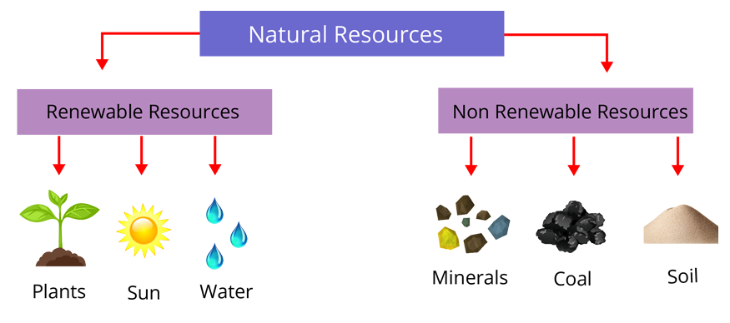

[*https://www.vedantu.com/biology/renewable-and-non-renewable-resources*](https://www.vedantu.com/biology/renewable-and-non-renewable-resources)